* Adding Certificate at JVM level(Copy this certificate to all the 3 nodes).

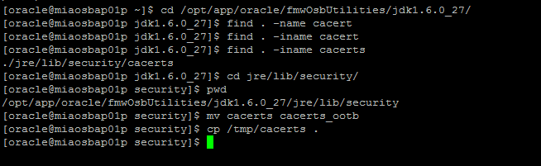

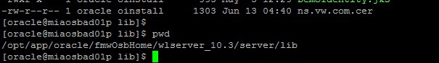

**Command to import certificate:-**

keytool -import -keystore DemoTrust.jks -trustcacerts -alias vwivds -file ns.vw.com.cer

password:- ***DemoTrustKeyStorePassPhrase***



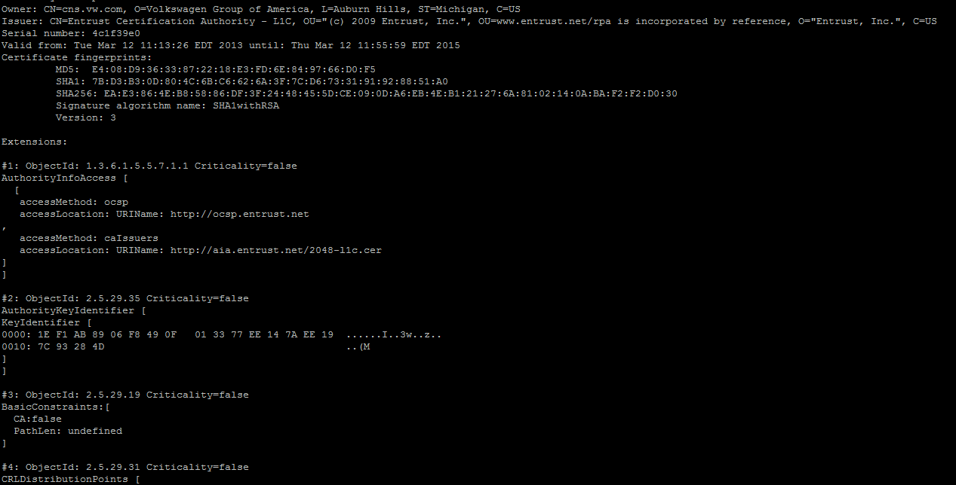 L

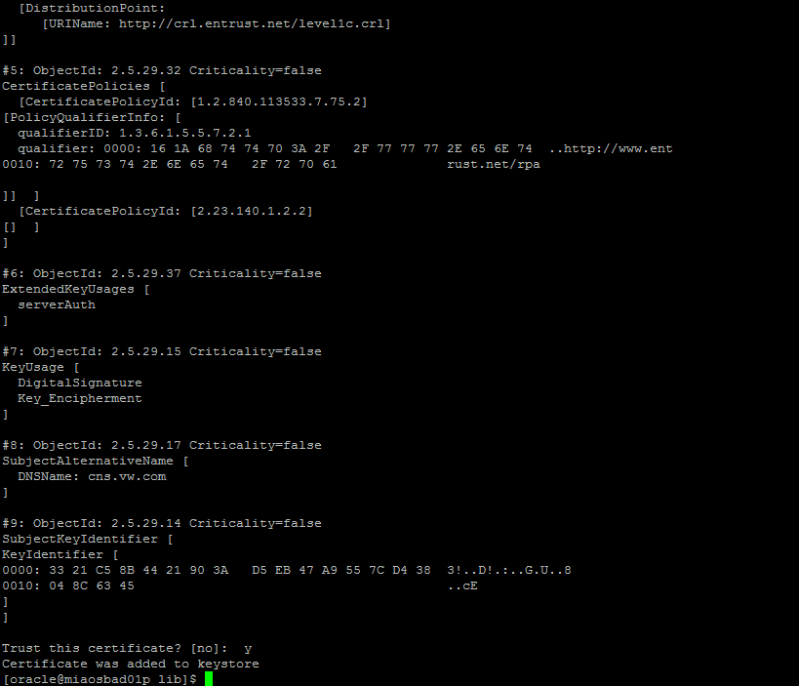

**Command to list all the certificates:-**

keytool -list -keystore DemoTrust.jks

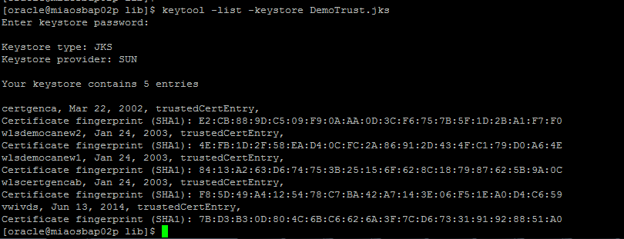

Restarted Admin and Managed servers.